Stewart's Theorem
# Source: AI Source: Provided by: [Data Path: Persons Table -> ID Column: 1, Name_En Column: Motasem Essam] -> From: [ChatGPT] on [7/25/2026]
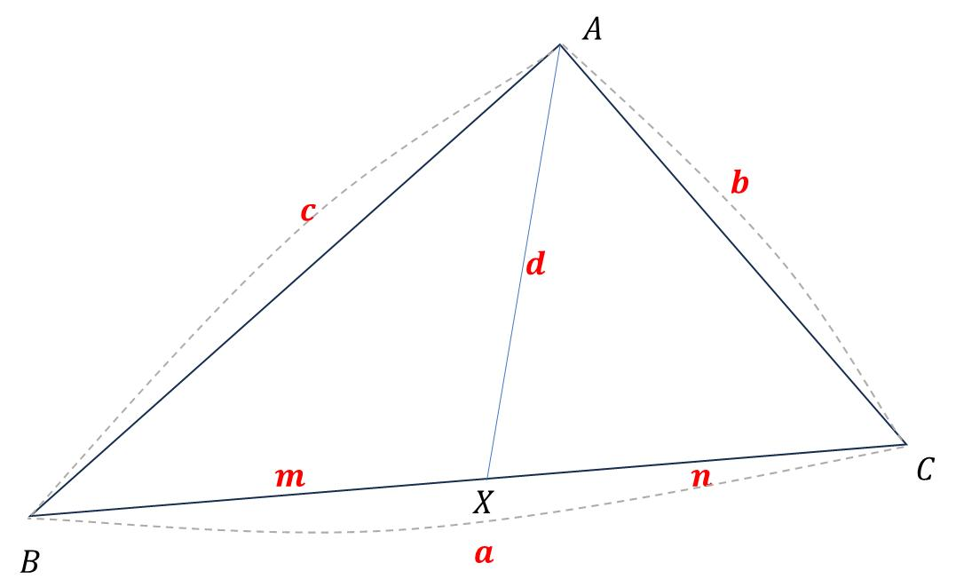
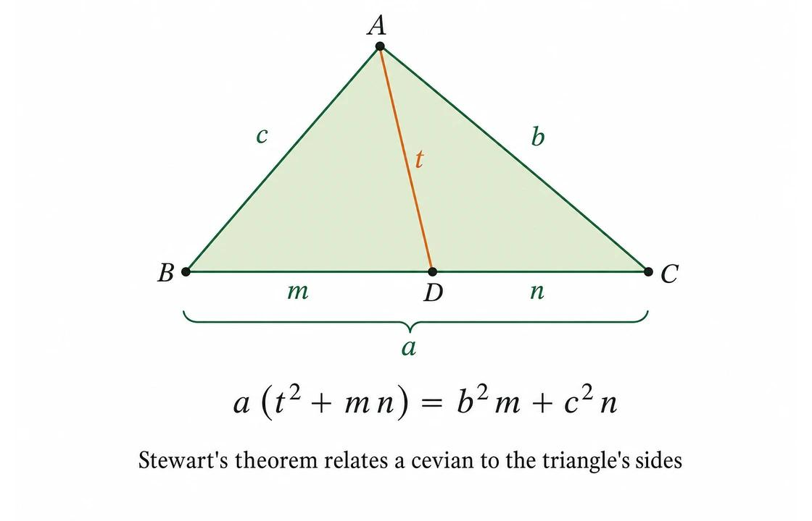
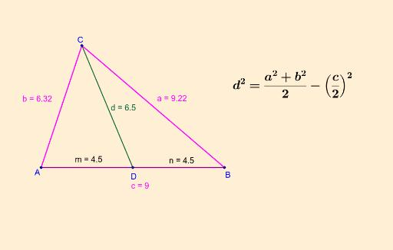
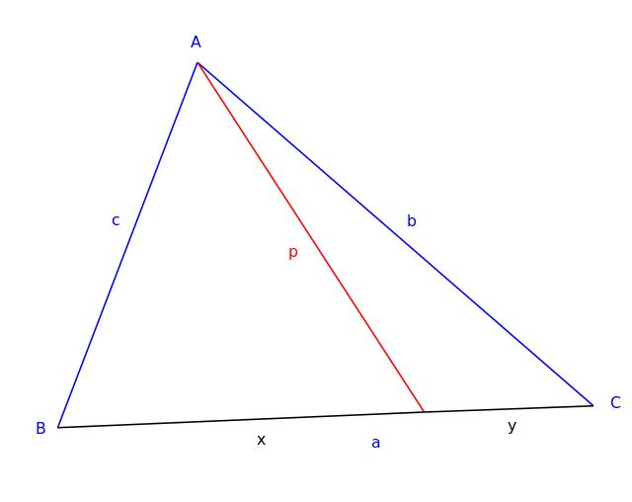

Definition
# Source: AI Source: Provided by: [Data Path: Persons Table -> ID Column: 1, Name_En Column: Motasem Essam] -> From: [ChatGPT] on [7/25/2026]
Stewart's Theorem is a theorem in triangle geometry that relates the lengths of the three sides of a triangle to the length of a cevian drawn from a vertex to the opposite side.
Consider $△ABC$, where $D$lies on $BC$. Let:
$$AD=d$$
and define:
$$BD=m, DC=n, BC=a$$
so that:
$$a=m+n$$
If:
$$AB=c, AC=b$$
then Stewart's Theorem states:
$$\boxed{b^{2}m+c^{2}n=a\left(d^{2}+mn\right)}$$
This is the standard form of Stewart's Theorem.
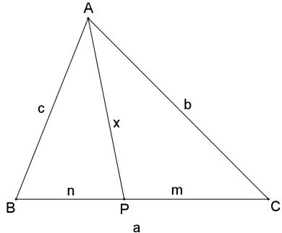

Simple Definition
# Source: AI Source: Provided by: [Data Path: Persons Table -> ID Column: 1, Name_En Column: Motasem Essam] -> From: [ChatGPT] on [7/25/2026]
Stewart's Theorem calculates the length of a cevian in a triangle when the relevant side lengths and the two segments created on the opposite side are known.
It connects:
$$\boxed{\text{Side Lengths}+\text{Cevian Length}+\text{Segment Ratios}}$$

Fundamental Configuration
# Source: AI Source: Provided by: [Data Path: Persons Table -> ID Column: 1, Name_En Column: Motasem Essam] -> From: [ChatGPT] on [7/25/2026]
Consider:
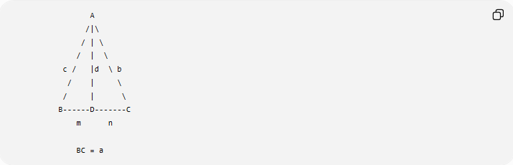
A
/|\
/ | \
/ | \
c / |d \ b
/ | \
/ | \
B------D-------C
m n

BC = a
Where:
$$AB=c \\ AC=b \\ BC=a \\ BD=m \\ DC=n \\ AD=d$$
Since $D$lies on $BC$:
$$\boxed{a=m+n}$$

Stewart's Formula
# Source: AI Source: Provided by: [Data Path: Persons Table -> ID Column: 1, Name_En Column: Motasem Essam] -> From: [ChatGPT] on [7/25/2026]
The theorem is:
$$\boxed{b^{2}m+c^{2}n=a\left(d^{2}+mn\right)}$$
Solving for the cevian $d$:
$$b^{2}m+c^{2}n=ad^{2}+amn \\ ad^{2}=b^{2}m+c^{2}n-amn$$
Therefore:
$$\boxed{d^{2}=\frac{b^{2}m+c^{2}n}{a}-mn}$$
and:
$$\boxed{d=\sqrt{\frac{b^{2}m+c^{2}n}{a}-mn}}$$

Meaning of the Variables
# Source: AI Source: Provided by: [Data Path: Persons Table -> ID Column: 1, Name_En Column: Motasem Essam] -> From: [ChatGPT] on [7/25/2026]
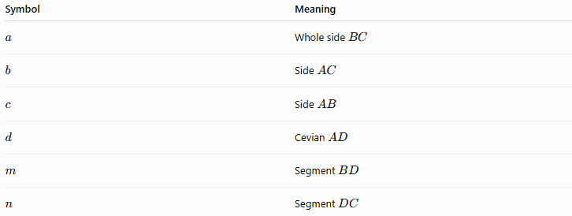
Symbol | Meaning
$$a$$ | Whole side $BC$
$$b$$ | Side $AC$
$$c$$ | Side $AB$
$$d$$ | Cevian $AD$
$$m$$ | Segment $BD$
$$n$$ | Segment $DC$
The important relationship is:
$$\boxed{a=m+n}$$

Example 1: Finding a Cevian
# Source: AI Source: Provided by: [Data Path: Persons Table -> ID Column: 1, Name_En Column: Motasem Essam] -> From: [ChatGPT] on [7/25/2026]
Suppose:
$$AB=13, AC=14, BC=15$$
and $D$divides $BC$such that:
$$BD=6, DC=9$$
Find $AD$.
Assign:
$$c=13, b=14, a=15 \\ m=6, n=9$$
Using Stewart's Theorem:
$$b^{2}m+c^{2}n=a\left(d^{2}+mn\right)$$
Substitute:
$${14}^{2}\left(6\right)+{13}^{2}\left(9\right)=15\left(d^{2}+6⋅9\right) \\ 196\left(6\right)+169\left(9\right)=15\left(d^{2}+54\right) \\ 1176+1521=15\left(d^{2}+54\right) \\ 2697=15d^{2}+810 \\ 1887=15d^{2} \\ d^{2}=125.8$$
Therefore:
$$\boxed{d≈11.22}$$
So:
$$\boxed{AD≈11.22}$$

Example 2: Finding an Unknown Side
# Source: AI Source: Provided by: [Data Path: Persons Table -> ID Column: 1, Name_En Column: Motasem Essam] -> From: [ChatGPT] on [7/25/2026]
Suppose:
$$BC=13, BD=5, DC=8 \\ AC=10, AD=7$$
Find $AB$.
Let:
$$a=13, m=5, n=8, b=10, d=7$$
Stewart's Theorem:
$$b^{2}m+c^{2}n=a\left(d^{2}+mn\right)$$
Substitute:
$${10}^{2}\left(5\right)+c^{2}\left(8\right)=13\left(7^{2}+5⋅8\right) \\ 500+8c^{2}=13\left(49+40\right) \\ 500+8c^{2}=1157 \\ 8c^{2}=657 \\ c^{2}=82.125$$
Thus:
$$\boxed{AB≈9.06}$$

Example 3: Median Formula
# Source: AI Source: Provided by: [Data Path: Persons Table -> ID Column: 1, Name_En Column: Motasem Essam] -> From: [ChatGPT] on [7/25/2026]
Stewart's Theorem has an especially important special case when the cevian is a median.
If $AD$is a median, then:
$$BD=DC$$
Therefore:
$$m=n=\frac{a}{2}$$
Starting with:
$$b^{2}m+c^{2}n=a\left(d^{2}+mn\right)$$
substitute:
$$b^{2}\frac{a}{2}+c^{2}\frac{a}{2}=a\left(d^{2}+\frac{a^{2}}{4}\right)$$
Divide by $a$:
$$\frac{b^{2}+c^{2}}{2}=d^{2}+\frac{a^{2}}{4}$$
Therefore:
$$\boxed{d^{2}=\frac{2b^{2}+2c^{2}-a^{2}}{4}}$$
So the length of the median is:
$$\boxed{d=\frac{1}{2}\sqrt{2b^{2}+2c^{2}-a^{2}}}$$
This is known as the median length formula.

Example: Median
# Source: AI Source: Provided by: [Data Path: Persons Table -> ID Column: 1, Name_En Column: Motasem Essam] -> From: [ChatGPT] on [7/25/2026]
Suppose a triangle has sides:
$$a=10, b=13, c=15$$
Find the median to side $a$.
Using:
$$d=\frac{1}{2}\sqrt{2b^{2}+2c^{2}-a^{2}}$$
we get:
$$d=\frac{1}{2}\sqrt{2\left({13}^{2}\right)+2\left({15}^{2}\right)-{10}^{2}} \\ d=\frac{1}{2}\sqrt{338+450-100} \\ d=\frac{1}{2}\sqrt{688} \\ \boxed{d=2\sqrt{43}}$$
approximately:
$$\boxed{d≈13.11}$$

Stewart's Theorem and Angle Bisectors
# Source: AI Source: Provided by: [Data Path: Persons Table -> ID Column: 1, Name_En Column: Motasem Essam] -> From: [ChatGPT] on [7/25/2026]
Stewart's Theorem can also be combined with the Angle Bisector Theorem.
If $AD$is an angle bisector, then:
$$\frac{BD}{DC}=\frac{AB}{AC}$$
Using the appropriate side notation:
$$\frac{m}{n}=\frac{c}{b}$$
This determines the values of $m$and $n$, which can then be substituted into Stewart's formula.
This produces a formula for the length of an angle bisector.
The resulting angle-bisector length formula is:
$$\boxed{AD=\frac{\sqrt{bc\left({\left(b+c\right)}^{2}-a^{2}\right)}}{b+c}}$$
where:
- $a=BC$,
- $b=CA$,
- $c=AB$.

Stewart's Theorem and Perpendicular Altitudes
# Source: AI Source: Provided by: [Data Path: Persons Table -> ID Column: 1, Name_En Column: Motasem Essam] -> From: [ChatGPT] on [7/25/2026]
An altitude is a special type of cevian.
If:
$$AD⊥BC$$
then $AD$is an altitude.
Stewart's Theorem can therefore be applied to altitude configurations as well.
For a right triangle, the theorem can produce familiar relationships involving the altitude to the hypotenuse.

Important Special Cases
# Source: AI Source: Provided by: [Data Path: Persons Table -> ID Column: 1, Name_En Column: Motasem Essam] -> From: [ChatGPT] on [7/25/2026]
Stewart's Theorem can be specialized for several important cevians:
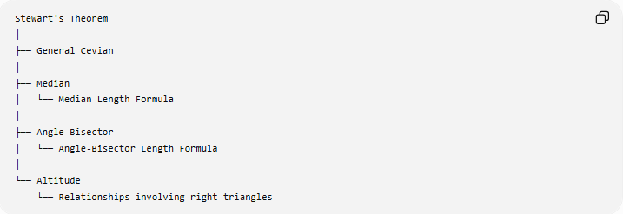
Stewart's Theorem
│
├── General Cevian
│
├── Median
│ └── Median Length Formula
│
├── Angle Bisector
│ └── Angle-Bisector Length Formula
│
└── Altitude
└── Relationships involving right triangles

Relationship to Cevians
# Source: AI Source: Provided by: [Data Path: Persons Table -> ID Column: 1, Name_En Column: Motasem Essam] -> From: [ChatGPT] on [7/25/2026]
Stewart's Theorem is specifically concerned with the length of a cevian.
A cevian connects a vertex to a point on the opposite side.
Examples:
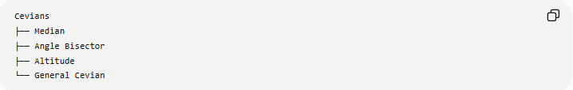
Cevians
├── Median
├── Angle Bisector
├── Altitude
└── General Cevian
Stewart's Theorem can therefore be viewed as a cevian-length theorem.

Proof Idea
# Source: AI Source: Provided by: [Data Path: Persons Table -> ID Column: 1, Name_En Column: Motasem Essam] -> From: [ChatGPT] on [7/25/2026]
A common proof uses the Law of Cosines.
Consider $△ABD$:
$$c^{2}=d^{2}+m^{2}-2dm\cos{θ}$$
where:
$$θ=∠ADB$$
For $△ACD$, the angle at $D$is supplementary to $θ$, so:
$$b^{2}=d^{2}+n^{2}+2dn\cos{θ}$$
Multiply the first equation by $n$:
$$c^{2}n=d^{2}n+m^{2}n-2dmn\cos{θ}$$
Multiply the second by $m$:
$$b^{2}m=d^{2}m+n^{2}m+2dmn\cos{θ}$$
Add them:
$$b^{2}m+c^{2}n=d^{2}\left(m+n\right)+mn\left(m+n\right)$$
Since:
$$m+n=a$$
we obtain:
$$\boxed{b^{2}m+c^{2}n=a\left(d^{2}+mn\right)}$$
which is Stewart's Theorem.

Why Stewart's Theorem Is Useful
# Source: AI Source: Provided by: [Data Path: Persons Table -> ID Column: 1, Name_En Column: Motasem Essam] -> From: [ChatGPT] on [7/25/2026]
Without Stewart's Theorem, a general cevian may be difficult to determine directly because the two smaller triangles do not usually form a right triangle.
Stewart's Theorem provides a direct relationship between:
$$\boxed{a,b,c,m,n,d}$$
so that if enough of these quantities are known, an unknown quantity can be calculated.

Comparison with Other Triangle Theorems
# Source: AI Source: Provided by: [Data Path: Persons Table -> ID Column: 1, Name_En Column: Motasem Essam] -> From: [ChatGPT] on [7/25/2026]
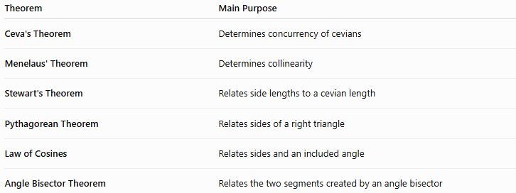
Theorem | Main Purpose
Ceva's Theorem | Determines concurrency of cevians
Menelaus' Theorem | Determines collinearity
Stewart's Theorem | Relates side lengths to a cevian length
Pythagorean Theorem | Relates sides of a right triangle
Law of Cosines | Relates sides and an included angle
Angle Bisector Theorem | Relates the two segments created by an angle bisector
A useful distinction is:
$$\boxed{\text{Ceva}→\text{Concurrency}} \\ \boxed{\text{Menelaus}→\text{Collinearity}} \\ \boxed{\text{Stewart}→\text{Cevian Length}}$$

Classification
# Source: AI Source: Provided by: [Data Path: Persons Table -> ID Column: 1, Name_En Column: Motasem Essam] -> From: [ChatGPT] on [7/25/2026]
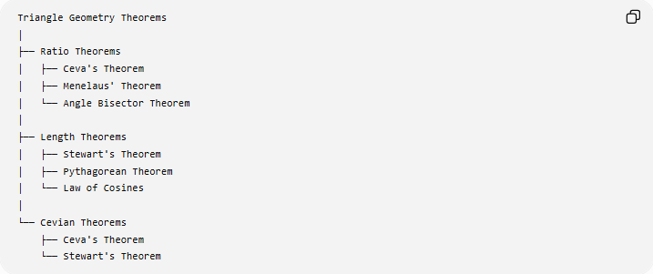
Triangle Geometry Theorems
│
├── Ratio Theorems
│ ├── Ceva's Theorem
│ ├── Menelaus' Theorem
│ └── Angle Bisector Theorem
│
├── Length Theorems
│ ├── Stewart's Theorem
│ ├── Pythagorean Theorem
│ └── Law of Cosines
│
└── Cevian Theorems
├── Ceva's Theorem
└── Stewart's Theorem

Key Formula
# Source: AI Source: Provided by: [Data Path: Persons Table -> ID Column: 1, Name_En Column: Motasem Essam] -> From: [ChatGPT] on [7/25/2026]
For:
$$BD=m, DC=n, BC=a=m+n \\ AB=c, AC=b, AD=d$$
Stewart's Theorem is:
$$\boxed{b^{2}m+c^{2}n=a\left(d^{2}+mn\right)}$$
For the cevian itself:
$$\boxed{d=\sqrt{\frac{b^{2}m+c^{2}n}{a}-mn}}$$

Key Points
# Source: AI Source: Provided by: [Data Path: Persons Table -> ID Column: 1, Name_En Column: Motasem Essam] -> From: [ChatGPT] on [7/25/2026]
- Stewart's Theorem relates triangle side lengths to a cevian.
- It applies to a general cevian drawn from a vertex to the opposite side.
- The opposite side is divided into two parts:
$$a=m+n$$
- Its main formula is:
$$\boxed{b^{2}m+c^{2}n=a\left(d^{2}+mn\right)}$$
- A median is a special case of a cevian.
- Stewart's Theorem produces the median-length formula:
$$\boxed{d=\frac{1}{2}\sqrt{2b^{2}+2c^{2}-a^{2}}}$$
- It can also be applied to angle bisectors and altitudes.
- A common proof derives it from the Law of Cosines.
- Unlike Ceva's Theorem, Stewart's Theorem does not primarily concern concurrency.
- Unlike Menelaus' Theorem, it does not primarily concern collinearity.

Conclusion
# Source: AI Source: Provided by: [Data Path: Persons Table -> ID Column: 1, Name_En Column: Motasem Essam] -> From: [ChatGPT] on [7/25/2026]
Stewart's Theorem is a fundamental triangle-length theorem that establishes a relationship between the sides of a triangle, the two segments of the opposite side, and the length of a cevian:
$$\boxed{b^{2}m+c^{2}n=a\left(d^{2}+mn\right)}$$
Its central role can be summarized as:
$$\boxed{\text{Triangle Side Lengths}⟷\text{Cevian Length}}$$
It is particularly useful for calculating medians, angle bisectors, altitudes, and general cevian lengths.

